
Programme | : | B.Tech. | Semester | : | Fall 22-23
Course | : | CSE3002:  Internet and Web Programming Lab | Slot | : | L9+L10
Faculty | : | Dr. M. Premalatha | Marks | : | 10

Date: 01-11-2022
Advait Deochakke
20BCE1143

Exercise –8
XML
Note:
- View your registration number in the title bar and snap a screenshot of output along with the title bar.
- Screenshot is required for every modifications of the web page.

- Apply styles as below using XML & CSS

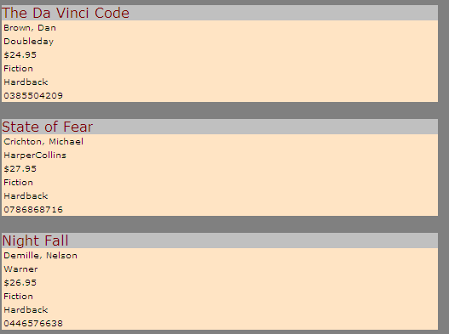

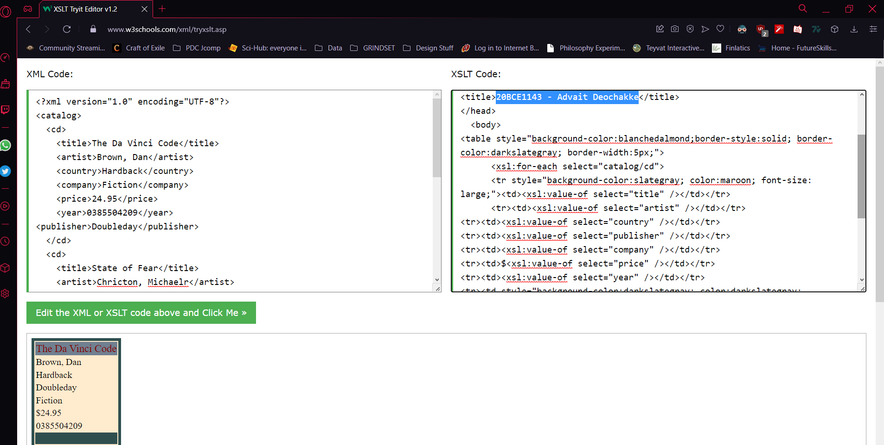

XML Code:

<?xml version="1.0" encoding="UTF-8"?>
<catalog>
<cd>
<title>The Da Vinci Code</title>
<artist>Brown, Dan</artist>
<country>Hardback</country>
<company>Fiction</company>
<price>24.95</price>
<year>0385504209</year>
<publisher>Doubleday</publisher>
</cd>
<cd>
<title>State of Fear</title>
<artist>Chricton, Michaelr</artist>
<country>Hardback</country>
<company>Fiction</company>
<price>27.95</price>
<year>0786886871</year>
<publisher>HarperCollins</publisher>
</cd>
<cd>
<title>Nightfall</title>
<artist>Damille, Nelson</artist>
<country>Hardback</country>
<company>Fiction</company>
<price>24.95</price>
<year>046657638</year>
<publisher>Warner</publisher>
</cd>
</catalog>

XSLT Code:

<?xml version="1.0" encoding="UTF-8"?>
<xsl:stylesheet version="1.0"
xmlns:xsl="http://www.w3.org/1999/XSL/Transform">
<xsl:template match="/">
<html>
<head>
<title>20BCE1143 - Advait Deochakke</title>
</head>
<body>
<table style="background-color:blanchedalmond;border-style:solid; border-color:darkslategray; border-width:5px;">
<xsl:for-each select="catalog/cd">
<tr style="background-color:slategray; color:maroon; font-size: large;"><td><xsl:value-of select="title" /></td></tr>
<tr><td><xsl:value-of select="artist" /></td></tr>
<tr><td><xsl:value-of select="country" /></td></tr>
<tr><td><xsl:value-of select="publisher" /></td></tr>
<tr><td><xsl:value-of select="company" /></td></tr>
<tr><td>$<xsl:value-of select="price" /></td></tr>
<tr><td><xsl:value-of select="year" /></td></tr>
<tr><td style="background-color:darkslategray; color:darkslategray; ">blank</td></tr>
</xsl:for-each>
</table>
</body>
</html>
</xsl:template>
</xsl:stylesheet>

- Apply XML DTD and XML Schema for the above Books Database

DTD :

<!DOCTYPE CATALOG [
<!ELEMENT CATALOG (CD+)>
<!ELEMENT CD (title+, artist+, country+, company+, price?, year+, publisher+)>
<!ATTLIST CD
title (#PCDATA)
artist (#pcdata)
country (Hardback|Paperback|Ebook) "Hardback"
company (Fiction|Thriller|Biography|Literature) "Fiction"
price (#PCDATA)
year (#pcdata)
publisher (HarperCollins|Doubleday|Warner)
>
]>

Schema :

<?xml version="1.0" encoding="UTF-8" ?>
<xs:schema xmlns:xs="http://www.w3.org/2001/XMLSchema">

<!-- definition of simple elements -->
<xs:element name="title" type="xs:string"/>
<xs:element name="artist" type="xs:string"/>
<xs:element name="country" type="xs:string"/>
<xs:element name="company" type="xs:string"/>
<xs:element name="price" type="xs:decimal"/>
<xs:element name="year" type="xs:integer"/>
<xs:element name="publisher" type="xs:string"/>

<!-- definition of complex elements -->
<xs:element name="cd">
<xs:complexType>
<xs:sequence>
<xs:element ref="title" maxOccurs="1" minOccurs="1"/>
<xs:element ref="artist" maxOccurs="1" minOccurs="1"/>
<xs:element ref="country" maxOccurs="1" minOccurs="1"/>
<xs:element ref="company" maxOccurs="1" minOccurs="1"/>
<xs:element ref="price" maxOccurs="1" minOccurs="0"/>
<xs:element ref="year" maxOccurs="1" minOccurs="1"/>
<xs:element ref="publisher" maxOccurs="1" minOccurs="1"/>
</xs:sequence>
</xs:complexType>
</xs:element>

<xs:element name="catalog">
<xs:complexType>
<xs:sequence>
<xs:element ref="cd" maxOccurs="unbounded"/>
</xs:sequence>
</xs:complexType>
</xs:element>

</xs:schema>

- Consider the following XML DTD
<?xml version="1.0"?>

<!-- 1. XML-Document -->
<!DOCTYPE catalog SYSTEM "cat.dtd">
<catalog>
<product>
<productname>cupboard</productname>
<storagenumber>3421</storagenumber>
<dimension unit="cm">
<width>120</width>
<heigth>180</heigth>
<depth>34</depth>
</dimension>
<description>oak veneer</description>
</product>
</catalog>
<?xml version="1.0"?>

<!-- 2. XML-Document -->
<!DOCTYPE catalog SYSTEM "cat.dtd">
<catalog>
<product>
<productname>mirror</productname>
<storagenumber>3455</storagenumber>
<dimension unit="m">
<width>1</width>
<heigth>1,5</heigth>
</dimension>
<description>blue frame</description>
<supplier>Schmid Co.</supplier>
<supplier>Mayer GmbH</supplier>
</product>
</catalog>
Deﬁne a possible XML Schema for the 2.XML documents.

COMMON SCHEMA :

<?xml version="1.0" encoding="UTF-8" ?>
<xs:schema xmlns:xs="http://www.w3.org/2001/XMLSchema">

<!-- definition of simple elements -->
<xs:element name="height" type="xs:decimal"/>
<xs:element name="width" type="xs:decimal"/>
<xs:element name="depth" type="xs:decimal"/>
<xs:element name="productname" type="xs:string"/>
<xs:element name="storagenumber" type="xs:integer"/>
<xs:element name="description" type="xs:string"/>
<xs:element name="supplier" type="xs:string"/>

<!-- definition of attributes -->
<xs:attribute name="unit" type="xs:string"/>

<!-- definition of complex elements -->

<xs:element name="dimension">
<xs:complexType>
<xs:sequence>
<xs:element ref="height" use="required"/>
<xs:element ref="width" maxOccurs="1" minOccurs="0"/>
<xs:element ref="depth" maxOccurs="1" minOccurs="0"/>
<xs:attribute ref="unit" use="required"/>
</xs:sequence>
</xs:complexType>
</xs:element>

<xs:element name="product">
<xs:complexType>
<xs:sequence>
<xs:element ref="productname" use="required"/>
<xs:element ref="storagenumber" use="required"/>
<xs:element ref="dimension" use="required"/>
<xs:element ref="description"/>
<xs:element ref="supplier"/>
</xs:sequence>
</xs:complexType>
</xs:element>

<xs:element name="catalog">
<xs:complexType>
<xs:sequence>
<xs:element ref="product" maxOccurs="unbounded"/>
</xs:sequence>
</xs:complexType>
</xs:element>

</xs:schema>

- Consider now an extension of our original DTD, where the element juicer has attributes.
<!ELEMENT juicers (juicer)*>
<!ELEMENT juicer (name, image, description, warranty?,
weight?, cost+, retailer)>
<!ATTLIST juicer id ID #REQUIRED
electric (true|false) #REQUIRED
type (press | gear | centrifugal) #REQUIRED>
<!ELEMENT name (#PCDATA)>
<!ELEMENT image (#PCDATA)>
<!ELEMENT description (#PCDATA)>
<!ELEMENT warranty (#PCDATA)>
<!ELEMENT weight (#PCDATA)>
<!ELEMENT cost (#PCDATA)>
<!ELEMENT retailer (#PCDATA)>
Create corresponding attributes in the XML schema.

New Simple Elements :
<!-- definition of new simple elements -->
<xs:element name="weight" type="xs:decimal"/>
<xs:element name="cost" type="xs:decimal"/>
<xs:element name="warranty" type="xs:string"/>
<xs:element name="retailer" type="xs:string"/>
<xs:element name="image" type="xsd:base64Binary"/>

<!-- definition of new attributes -->
<xs:attribute name="id" type="xs:string">
<xs:simpleType>
<xs:restriction base="xs:integer">
<xs:pattern value="[0-9]+"/>
</xs:restriction>
</xs:simpleType>
</xs:attribute>
<xs:attribute name="electric" type="xs:string">
<xs:simpleType>
<xs:restriction base="xs:string">
<xs:pattern value="(\btrue\b|\bfalse\b){1}"/>
</xs:restriction>
</xs:simpleType>
</xs:attribute>
<xs:attribute name="type" type="xs:string">
<xs:simpleType>
<xs:restriction base="xs:string">
<xs:pattern value="(\bpress\b|\bgear\b|\bcentrifugal\b){1}"/>
</xs:restriction>
</xs:simpleType>
</xs:attribute>

<!-- definition of new complex elements -->

<xs:element name="juicer">
<xs:complexType>
<xs:sequence>
<xs:element ref="productname"/>
<xs:element ref="image"/>
<xs:element ref="description"/>
<xs:element ref="warranty" maxOccurs="1"/>
<xs:element ref="weight" maxOccurs="1"/>
<xs:element ref="cost" minOccurs="1"/>
<xs:element ref="retailer"/>
<xs:attribute ref="ID" use="required"/>
<xs:attribute ref="electric" use="required"/>
<xs:attribute ref="type" use="required"/>
</xs:sequence>
</xs:complexType>
</xs:element>

<xs:element name="juicers">
<xs:complexType>
<xs:sequence>
<xs:element ref="juicer" maxOccurs="unbounded"/>
</xs:sequence>
</xs:complexType>
</xs:element>

<xs:element name="catalog">
<xs:complexType>
<xs:sequence>
<xs:element ref="product" maxOccurs="unbounded"/>
<xs:element ref="juicers" maxOccurs="unbounded"/>
</xs:sequence>
</xs:complexType>
</xs:element>

------------------------------------------------------------------------------------------------------------

